2024 Micro Extract A and B
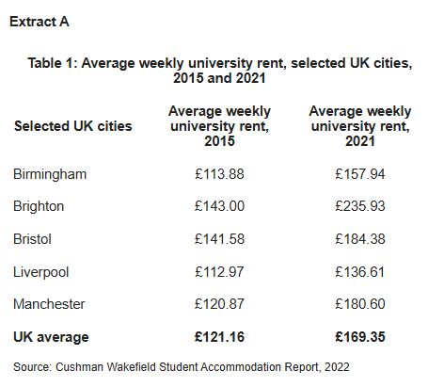

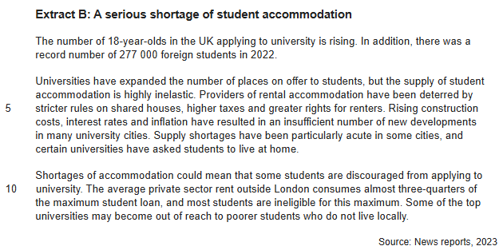

Example answers paper 1 – Micro 2025
Q2. Using extract A, how has the supply of university and private rental accommodation failed to match the increase in student numbers between 2015 and 2021 (4 marks)
Mark the three samples below. Say why you have given each the respective marks.
Sample A
The number living at home has gone up more than any other type of accommodation. A lot of students must like living at home, apart from the foreign students who can’t. The number of students who are going to university has accelerated over the years, there was a record number of students in 2022. Rising construction costs, higher interest rates and an insufficient number of developments have afflicted University cities. This could mean some students are discouraged from applying to university. This is a clear sign of market failure in the student accommodation market, which is a merit good.
Mark
Comments

Sample B
The number of full-time students, shown in figure 1, has risen from 1,700,000 to 2,100,000. This is an increase of 400,000 or 23.5% in the period 2015 to 2021. However, the amount of University and Private Rental accommodation has not kept pace, such that the demand for accommodation has risen at a higher rate than supply. University accommodation was 350,000 in 2015 and has stayed at about the same level. Private rental offered 650,000 places in 2015 and this rose slightly to 750,000. Therefore, the change in the sum of private and university accommodation was just 100,000 places or 10%. We can see the effect of this greater demand for these places in the change in UK average rents from £121.16 to £169.35 a change of 39.8%.
Mark
Comments

Sample C
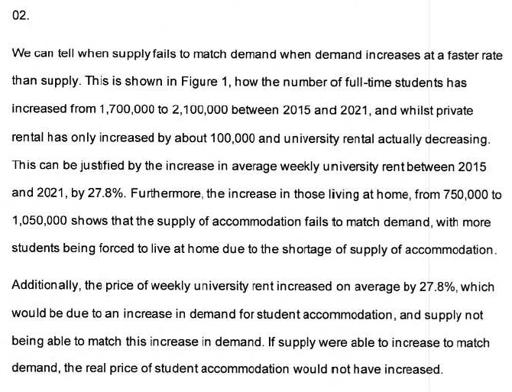
Mark
Comments

Explanation A
First part of the answer comments on trends in the extract indicated by the question but has no data. The second sentence is a value judgement, hence meaningless. The last half of the answer relates to extracts B and C, not required by the question, and any statements made are unrelated to the question. Zero marks.

Explanation B
Relevant figures of change in student numbers (in absolute terms and in percentage terms) are calculated. These are contrasted with the two types of accommodation mentioned in the extract namely private and uni accommodation, and here again changes are expressed in absolute and percentage terms. These are then contrasted in terms of supply and demand. Furthermore evidence of excess demand for these types of accommodation are supported by the very large change in rental costs for universities accommodation. (An alternative support could be offered by the greater number of students living at home.) 4 marks.

Explanation C: As above re: explanation B - Actual Student Answer 4 marks

A note if ever comparing Percentages: The data here does not contain any percentage scores BUT if you are ever asked to compare percentages make sure you refer to the change in Percentage Points…..never, never calculate a percentage change of percentages.
Example: Inflation changes from 10% to 11%. This is a 1 percentage point increase in inflation. It is NOT a 1 / 10 = 10% change in inflation. CHANGES IN PERCENTAGES ARE ALWAYS TERMED INCREASES OR DECREASES IN PERCENTAGE POINTS.

Q3 – 9 MARKER
“Universities have expanded the number of places on offer to students, but the supply of student accommodation is highly inelastic.”
With the help of a diagram, explain the impact of the increase in the number of students attending University on the market for student accommodation.

Mark the three samples below (pages 5 to 7)
Sample A
An increase in the number of students demanding accommodation will raise aggregate demand (“AD”) in the economy, so that Real GDP will increase as there is more expenditure on accommodation. The increase in aggregate demand will raise inflation and close any negative output gap. The foreign students expenditure will also help to balance any Balance of Payments deficit on the current account as foreign students are buying UK services (accommodation), and this will increase UK exports of services.
The diagram below shows the increase in AD, and reduction of negative output gap. I have also shown this on the PPF diagram, and production of goods and services increases towards the PPF (hence Economic Growth).
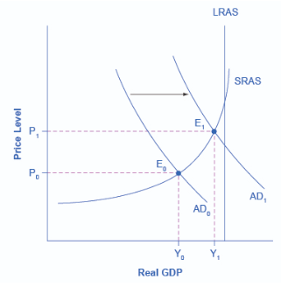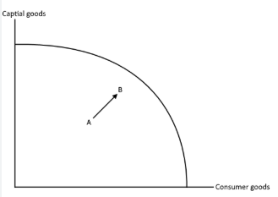
Move A to B shows actual Economic Growth

The increase in demand has not produced an equal increase in supply, so there is persistent excess demand. Increases in demand should always push increases in supply, as there will be more profits for the suppliers by increasing supply of accommodation. This is the market failure – it is a missing market.
Mark & Comments

Sample B
The number of students attending University has increased from 1.7m to 2.2 million, therefore demand for Student accommodation has increased. The demand for Student accommodation is a derived demand. The greater the number of students demanding university education, the greater the demand for student accommodation. The quote from Extract B tells us that the supply of student accommodation is price inelastic. This means that for a given percentage increase in quantity demanded, there will be a far greater percentage increase in price. We can see this in the diagram below.
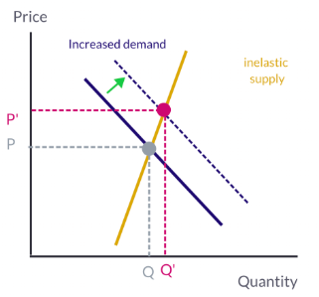
Rent
The inelastic supply curve occurs because suppliers of accommodation find it difficult to expand the quantity supplied in response to higher prices. Naturally suppliers are seeking to maximise revenue, but the supply curve tells us nothing of profits and the inelastic nature of the curve highlights the issues for suppliers, namely planning restrictions that create a time lag between applying to build more accommodation, convert houses to flats etc. and the delivery of such building projects. Furthermore, rising construction costs may have reduced potential profits and therefore only significant increases in rents might prompt expansion of supply. Greater rights for renters have made renting to students less attractive, such that only far higher rents would appeal to suppliers of student accommodation.

Mark & Comments

Sample C (Student Example)
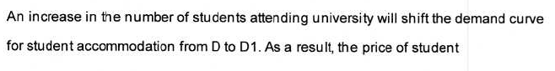
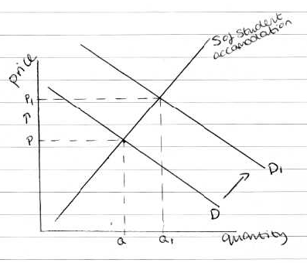
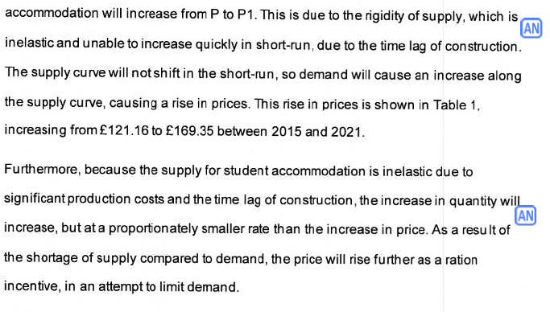
Mark & Comments

Explanation A.
The question clearly asks about the “market for student accommodation”. Therefore, the student is directed to draw a supply demand diagram. There is nothing that suggest anything macroeconomic ie AD-AS etc., is required.
Furthermore, the question gives two clear prompts towards what the diagram should show. Firstly the quote “universities have expanded the number of places on offer to students, but the supply of student accommodation is highly inelastic” supports the idea that more students are at university (we know this from q2, we also know that rents have risen strongly), but that the supply of accommodation is price inelastic (ie we need to draw an almost vertical supply curve). Furthermore, the question mentions the “impact of the increase in the number of students at university”.
So we are looking for a supply demand diagram showing an increase in the number of students at Uni. This can only come from either an increase in demand or an increase in supply. We also know that ONLY an increase in demand will raise rental costs (in increase in supply will lower rental costs). So it’s pretty clear that we need to show an increase in demand with an almost vertical (inelastic) supply curve.
The last para in Sample A is complete rubbish: here it is with annotations
There is no reason that a change in Demand should create any change in Supply. Yes - an increase in demand will create an expansion in supply, but there will be no corresponding shift in the supply curve. Shifts in Demand NEVER create shifts in Supply and vice versa.

The increase in demand has not produced an equal increase in supply, so there is persistent excess demand. Increases in demand should always push increases in supply, as there will be more profits for the suppliers by increasing supply of accommodation. This is the market failure – it is a missing market.
Supply / Demand tells us nothing about profits, simply about market price and quantity traded. It does tell us about Revenue, Expenditure (both = P x Q)
No – there is no “missing market” – this only applies to Public Goods, which won’t exist unless Govt pays for them

(1-2 marks)

Explanation B:
Per above explanation, there are deliberate clues in the extract quoted and question indicating the diagram required. Typically for a 9 marker two short paragraphs are required, in addition to diagram.
Our first para can explain the diagram in the most basic and simple terms, (in our case “what is the impact”) – we can explain the increase in demand and impact of the inelastic supply equalling higher prices relative to any expansion of quantity. I mentioned the idea of derived demand (you could also consider the two services - higher education and student accommodation – as complementary like fish and chips). If you are stuck with ideas here, you could even do a definition of what for example is “Demand” (“the quantity of a good or service that consumers are willing and able to purchase at various prices during a specific time period”).
The second para has to go deeper to fully answer the question – in this case we could say
EITHER why the supply of accommodation might be price inelastic and therefore refer back to Extract B (as it is cited in the question). Bring in and explain the impact of things like Building Regulations, making the market less responsive to price signals.
OR, we can bring in the market mechanism if desired. Can drill down into the Signalling, Incentive and Rationing Functions; describe how a rise in demand for accommodation (shift in D curve up, right) leads to excess demand, leads to higher prices, leads to expansion in quantity Supplied, contraction in quantity Demanded to a new equilibrium.
(8-9 marks)

Explanation C – Actual AQA Student Answer scored 8/9 (Why do you think they lost 1 mark?)

Section B – Essay 1
Price comparison websites were used to purchase 53% of car insurance policies in 2017, improving competition and reducing prices for consumers. In other sectors, dominant firms such as Amazon have used innovation to capture market share. In the UK, 70% of online consumers say that Amazon is the first online retailer they visit when buying goods.
Explain how perfect competition should lead to outcomes which are both productively and allocatively efficient.
[15 marks]
15 marker = a short definition of a point in the title and then 3 KAA paragraphs

Just one hopefully reasonable example:

Perfect Competition is a market structure with four assumptions, namely many buyers and sellers, perfect information, homogenous goods and freedom of entry and exit for firms. These four assumptions result in firms being Productively and Allocatively efficient in the long run (and under certain conditions) also in the short run.
(Para 1)
In the short run (when at least 1 factor of production is fixed), it is possible for a firm to make supernormal profits in a perfectly competitive market. In the short run, a firm may have an advantage of efficiency or technology that reduces costs. This can be seen in the diagram below – the market sets price at P, and as the firm is assumed to profit maximise, and given assumptions above is a price taker in the market, setting quantity at the point where MC crosses MR. In this case the quantity produced and sold by the firm (QFirm) is where Price = Marginal Cost. (Point A). This is allocatively efficient as the quantity produced by the firm stops when the marginal costs (the addition cost to the economy of producing an extra good) is greater than the price that a consumer is willing to pay (ie the utility that the extra good brings to the economy). In all of the production up to this point, the marginal cost per unit have been less than the utility derived from consumption by consumers, represented by the price. The perfectly competitive firm will ALWAYS be allocatively efficient.
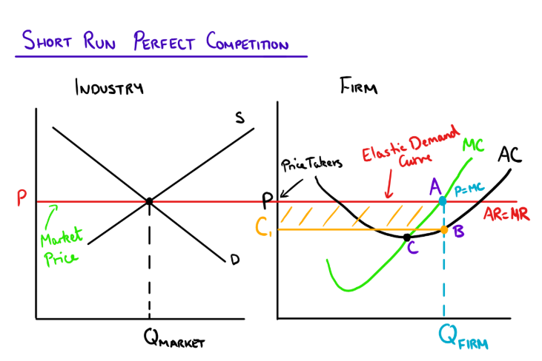

(Para 2)
In the above diagram the Firm is not Productively efficient. This is because the average cost of the good being produced is not at the lowest possible cost on the firm’s average cost curve. This means that the cost of goods being made is higher than the lowest possible point. This is shown on the diagram above at point B at the output quantity of QFirm. For the firm to be Productively efficient, production would have to take place at Quantity C – the lowest point on the AC curve. This is by definition where the MC curve cuts up and through the AC curve. However, when the firm is making super normal profits by profit maximising, setting Quantity output at MC=MR, this is not at the point of productive efficiency. As we shall see below this does happen in the long run, when all factors of production are variable and the assumptions of perfect competition, mean that new firms become aware of the supernormal profits being made, enter the market supplying the same homogenous product, and as a result the demand per firm falls as more firms contest the market.

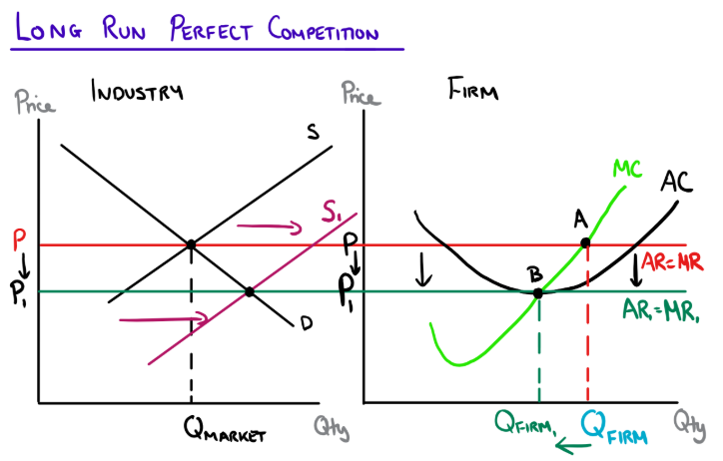

(Para 3)
In the above diagram we can see a perfectly competitive firm in the long run, where new entrants increase the market supply, eroding supernormal profits, pushing prices down and lowering a firm’s profit maximising output from point A to point B. At Point B the firm is both allocatively and productively efficient, producing at QFirm1 where Price = MC, and at the lowest point on the AC curve where MC cuts up through AC. Under the assumptions of perfect competition, new entrants will continue to enter the market as long as there are and supernormal profits to be made. Once these are eroded, new entrants will cease and the market will stabilise at a level of normal profit, and stable equilibrium. This is a highly desirable outcome for the economy as a whole and consumers especially. The above diagram (right hand side, after fall in price) can also represent a firm in the short run where no supernormal profits are made and therefore there is a stable equilibrium where the firm is producing at a point of both allocative and productive efficiency.

