15 Marker Exemplar – taken from 2023 Paper 3
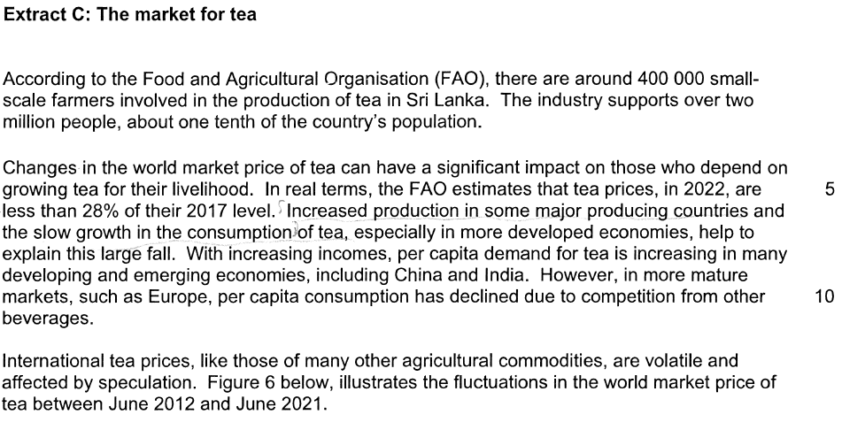
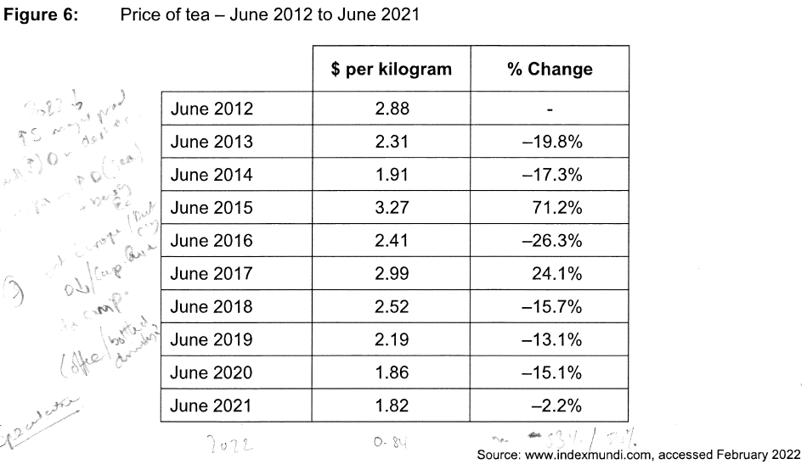
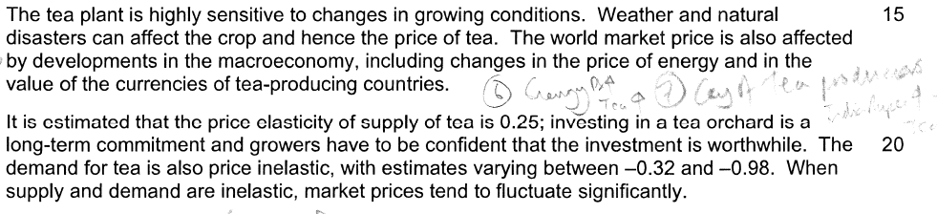

Explain possible reasons for fluctuations in the world market price of tea.
3 2
[15 marks]
The price of tea in a competitive market is determined by market supply and demand.
S
Market for Tea
Price
D2
P₃
D1
P₂

D3
P₁
Quantity
Q₄
Q₃
Q₁
Q₂

Tea is a normal good, which means as consumers income rises, they want to consume more tea. “With rising incomes, per capita demand for tea is increasing….” (Extract C). This shifts demand from D₁ to D₂. It will cause excess demand from Q₁ to Q₃. Therefore, supply will expand along the curve to meet the demand and demand will contract. This will lead to a rise in price from P₁ to P₂. As supply is inelastic (0.25), a small change in demand leads to a large fluctuation in price.

Increase in competition can cause PED to be more elastic and also shift Demand to the left (D₂ – D₁). Following a similar pattern, price could fall (P₂ – P₁) [JF note how / why? PES?]

Another reason for fluctuation in price is due to shifts of supply. “Tea plant is sensitive to changes in growing conditions” (Extract C). One reason why supply might shift to the right is if nice weather throughout the year causes more tea to be produced per square mile of land. It shifts supply to the right (S₁ – S₂). As tea is only a small percentage of household’s income, demand for tea is price inelastic, “varying between -0.32 and -0.98” (line 21). This means a shift in supply will cause a large change in price (P₁ – P₂)

Market for Tea (FIG 2)
S1
Price
P1
S2

P2

D
Quantity

Q2
Q1

Another reason for fluctuation is speculation. This is when consumers / firms see the price of tea rising, and decide to buy more tea now rather than later. This will cause a further shift in demand in (Fig 1, D₂ – D₃) causing the equilibrium position to go from P₂Q₂ to P₃Q₄, causing a further rise in price. The reverse can also happen. When the price of tea is falling, speculation will cause a further fall in the tea price.

Mark scheme
