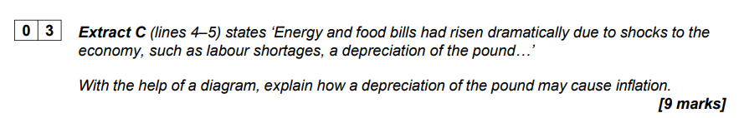
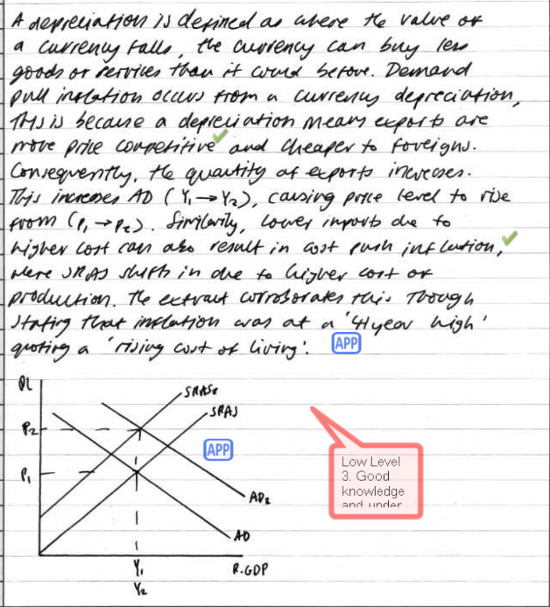
The above scored 7/9 – not bad. Candidate did a good job describing factors / impact of higher AD on inflation BUT could have described the chain of reasoning for why SRAS shifts up/right. (The extract mentions Labour shortages….very likely to lead to higher wages!) What else drove the higher cost of production? How / why did it increase inflation?
Also candidate could have clarified that “depreciation” relates to the fall in the value of a currency vs another currency in a Floating Currency Regime (as opposed to a Fixed Rate or Pegged Currency Regime).

Mark Scheme
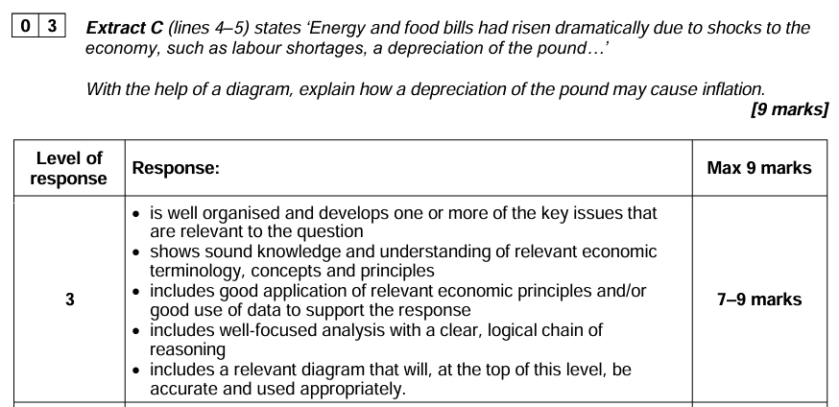
(top level of mark scheme)
Mark Scheme:
An AD/AS diagram which shows SRAS shifting leftward is likely to be used. Equally, some candidates may just show AS shifting leftward. Some candidates may consider the effect of a depreciation on net trade and AD rising.
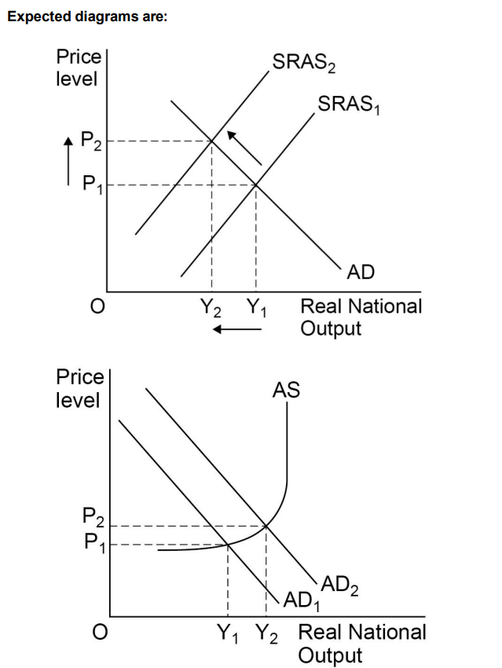
Relevant issues include:
• definitions/explanations: depreciation, the exchange rate, inflation
• explaining the causes of a depreciation of the currency
• explaining the effect of a depreciation on raising the cost of imports
• linking increased import costs to cost-push inflation
• explaining the effect of a depreciation creating more competitive exports and rising AD
• explaining the effects on domestic consumption and rising AD
• linking rises in AD to demand-pull inflation • considering how elasticity affects the relative changes in imports and exports

Examiners Report:
Question 3
In this question, students were asked to explain how depreciation of the pound may cause inflation. Many students went down either the route of explaining demand-pull inflation with the effects on net trade or cost-push inflation with the effects on the cost of imports. Better responses analysed both effects. Weaker answers failed to include a relevant diagram or focused solely on potential causes of a depreciation. Some weaker answers also focused on causes of inflation not linked to the exchange rate eg the war in Ukraine.

