Evaluate the likely microeconomic impacts of an increase of the UK minimum wage to £10 per hour. (25)

The minimum wage is the lowest legal amount a firm can pay an employee for an hour’s work, it is currently at £9.50 and an increase to £10 would benefit some workers but possibly at a cost to others and firms as well. We have a minimum wage to protect the lowest paid workers and ensure that people in full time work are not living in “working poverty”, this increase in the minimum wage will increase earnings for the poorest in society and could lift them out of poverty.
One argument against increasing the minimum wage is that it will create unemployment in competitive labour markets. If labour markets are competitive (many firms and workers, wage taking, perfect information, low barriers to entry) then the wage is set at the equilibrium of the supply of labour (the workers) and the demand for labour (firms). Here the wage is where the amount of people willing and able to work matches the amount of labour firms want to hire given their Marginal Revenue Product of Labour. An increase in the minimum wage would set a price floor for the wage in the market above the equilibrium so that the original wage, w1, is now illegal to pay. At this higher wage, workers become more expensive to hire and some firms will not be able to afford to pay as many workers. Also, capital may become a comparatively cheaper factor of production, so they substitute labour for capital. This combined mean that the quantity of labour demanded falls from Q1 to Q2 at the higher wage w2. This means that Q1-Q2 workers have been fired. Also, more labour might want to work at this higher wage, so the quantity of labour supplied increases from Q1 to Q3. This creates an overall real-wage unemployment of Q3-Q1.
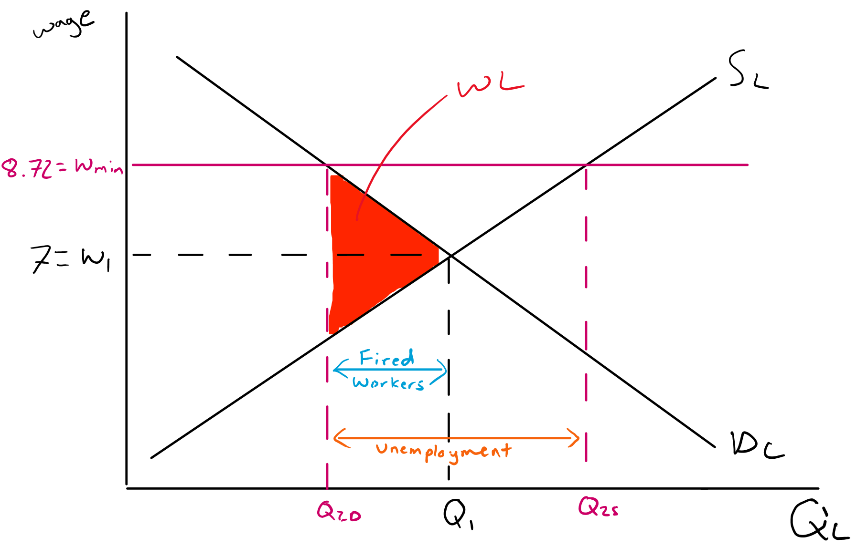
£9.50
£10
However, this might not be the case. Firstly, there is the wage efficiency theory which states that as workers are paid more, they feel more invested in their work and increase productivity. This in turn will increase all workers’ MRPL and therefore shift the DL curve outwards. This will create a new equilibrium at W2Q3 rather than W2Q2 and increase employment in the economy. Also, even if the wage efficiency theory does not hold in jobs where workers cannot easily increase productivity with an increase of wages, if the Supply and Demand for labour are relatively inelastic the increase in unemployment from the minimum wage will be quite small.
On the other hand, if the market is monopsonistic then a minimum wage might increase employment in an industry where the monopsony uses its power to supress wages below the competitive equilibrium level. If a monopsony (one buyer of labour), for example the NHS for nurses, sets wages at the quantity where MCL=MRPL but at the lower wage=ACL then the number of workers and wages will be lower than if the market was competitive. This is because nurses cannot choose to work for competitors as the NHS is the main employer of nursing labour in the UK. An increase in the minimum wage will make the MCL=ACL until the ACL>min wage, creating a new profit maximising equilibrium form the monopsony at Q2W2. Here the firm increases the number of workers hired when the minimum wage increases.
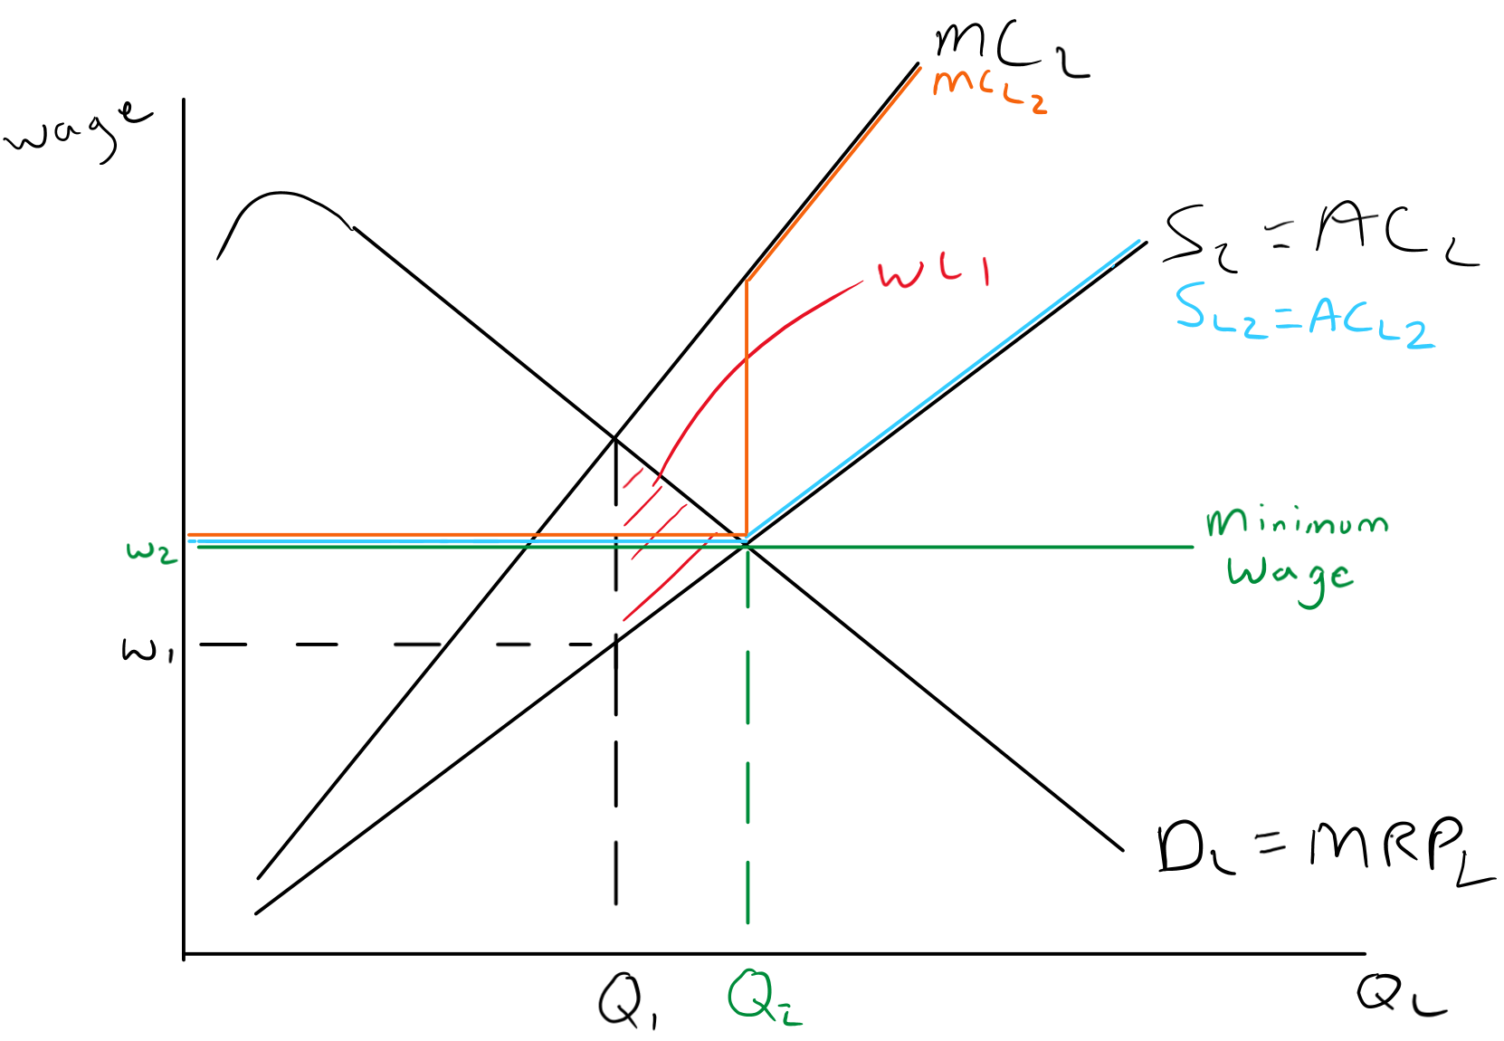
However, this is only the case if the minimum wage is below or equal to the competitive market equilibrium at SL=DL. Once the minimum wage starts rising above that, then unemployment increases further. Secondly, nurses are paid more than the minimum wage so actually the increase in minimum wage to £10 an hour might not influence their pay and quantity at all. Also in the long run, big firms with monopsony power will be incentivised to replace workers with capital, reducing their demand for labour over time and possibly increasing unemployment. An example here might be Transport for London and replacing guards with ticket barriers and machines. As employees ask for higher wages they will invest more heavily in automating their systems and reducing the amount of labour employed.
Overall, the impacts of the minimum wage increase depend on the markets it affects and who in the economy we are looking at. For most of the low paid labour, a minimum wage increase will improve their earning power, lift people out of poverty, reduce inequality in the economy, and will even influence wages above the minimum wage as well. If people can earn a higher wage for basic jobs, then those in higher skilled work have more bargaining power to ask for more wages in their work to keep the differential constant. While some workers may lose their jobs, this is unlikely to happen in the short run as most low paid work markets have some form of monopsony power (Tesco, McDonalds etc). In the long run however, as capital becomes variable, firms might choose to replace labour with capital (self-checkout machines in supermarkets) and we might see a greater increase in unemployment.
For firms an increase in the minimum wage will increase their costs and hurt their profitability. However, again this might only be in the short run (as they are more incentivised to invest in capital and increase productivity, this happens in France where the minimum wage is higher) and the wage efficiency theory states that workers might become more productive anyways with a higher wage.
Finally, an increase in the minimum wage will have a minimal impact on most people in the UK. Workers far above the minimum wage will not see any effects on their wages and only see an impact if the increase in minimum wage feeds through to an increase in prices leading to their real income falling.

