Evaluate the benefits of increased Trade Union membership and power within the UK. (25)

A trade union is a group of workers who join together and use collective bargaining power to increase the pay and working conditions of its members in the industry is operates. Examples of trade unions include UNITE and RMT. Trade unions exist to counter firms’ monopsony power in wage setting and to provide protection for workers against unfair treatment. However, some argue that trade unions only increase unemployment and harm workers who do not get to keep their jobs.
One argument against increasing trade union membership and power is that it will create unemployment in competitive labour markets. If labour markets are competitive (many firms and workers, wage taking, perfect information, low barriers to entry) then the wage is set at the equilibrium of the supply of labour (the workers) and the demand for labour (firms). Here the wage is where the amount of people willing and able to work matches the amount of labour firms want to hire given their Marginal Revenue Product of Labour. An increase trade union power will allow workers to negotiate a higher wage for workers employed in that industry. This would set a price floor for the wage in the market above the equilibrium so that the original wage, w1=£10 per hour, is now unacceptable to pay. At this higher wage (£12), workers become more expensive to hire and some firms will not be able to afford to pay as many workers. Also, capital may become a comparatively cheaper factor of production, so they substitute labour for capital. This combined mean that the quantity of labour demanded falls from Q1 to Q2 at the higher wage w2. This means that Q1-Q2 workers have been fired. Also, more labour might want to work at this higher wage, so the quantity of labour supplied increases from Q1 to Q3. This creates an overall real-wage unemployment of Q3-Q1.
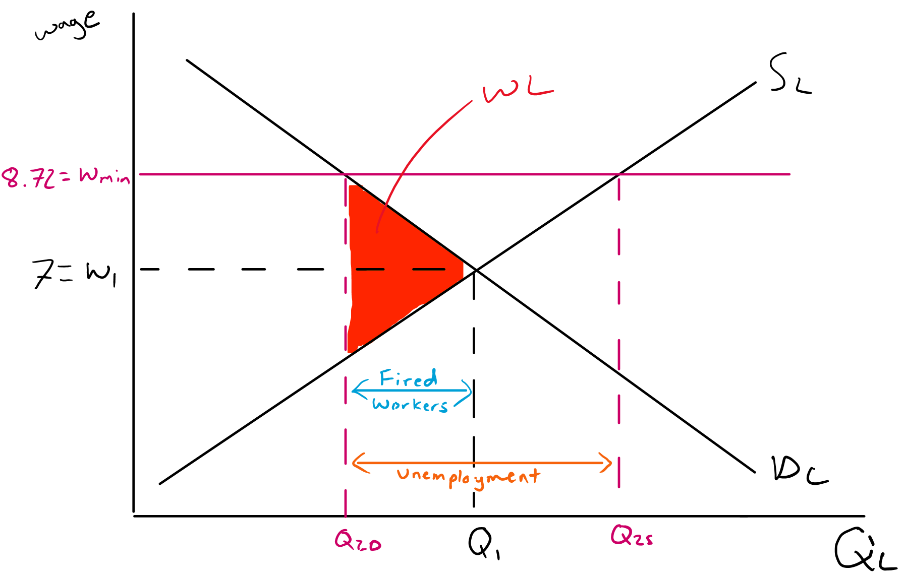
£12
£10
However, this might not be the case. Firstly, trade unions argue that they provide essential training, support, and quality assurance for their workers. Protected and trained workers should be better at their jobs and increase their productivity. This in turn will increase all workers’ MRPL and therefore shift the DL curve outwards. This will create a new equilibrium at W2Q3 rather than W2Q2 and increase employment in the economy. Also, if the Demand for labour are relatively inelastic (the workers are integral to the production of the product) the increase in unemployment from the trade union will be quite small.
On the other hand, if the market is monopsonistic then the increase in trade union power might increase employment in an industry where the monopsony uses its power to supress wages below the competitive equilibrium level. If a monopsony (one buyer of labour), for example the TfL for tube drivers, sets wages at the quantity where MCL=MRPL but at the lower wage=ACL then the number of workers and wages will be lower than if the market was competitive. This is because tube drivers cannot choose to work for competitors as TfL is only main employer of drivers in London. An increase power for RMT (the drivers’ union) increases their bargaining power and creates a bilateral monopoly. They will bargain for a higher minimum wage for their drivers which will make the MCL=ACL until the ACL>min wage, creating a new profit maximising equilibrium form the monopsony at Q2W2. Here the firm increases the number of workers hired when the minimum wage increases.
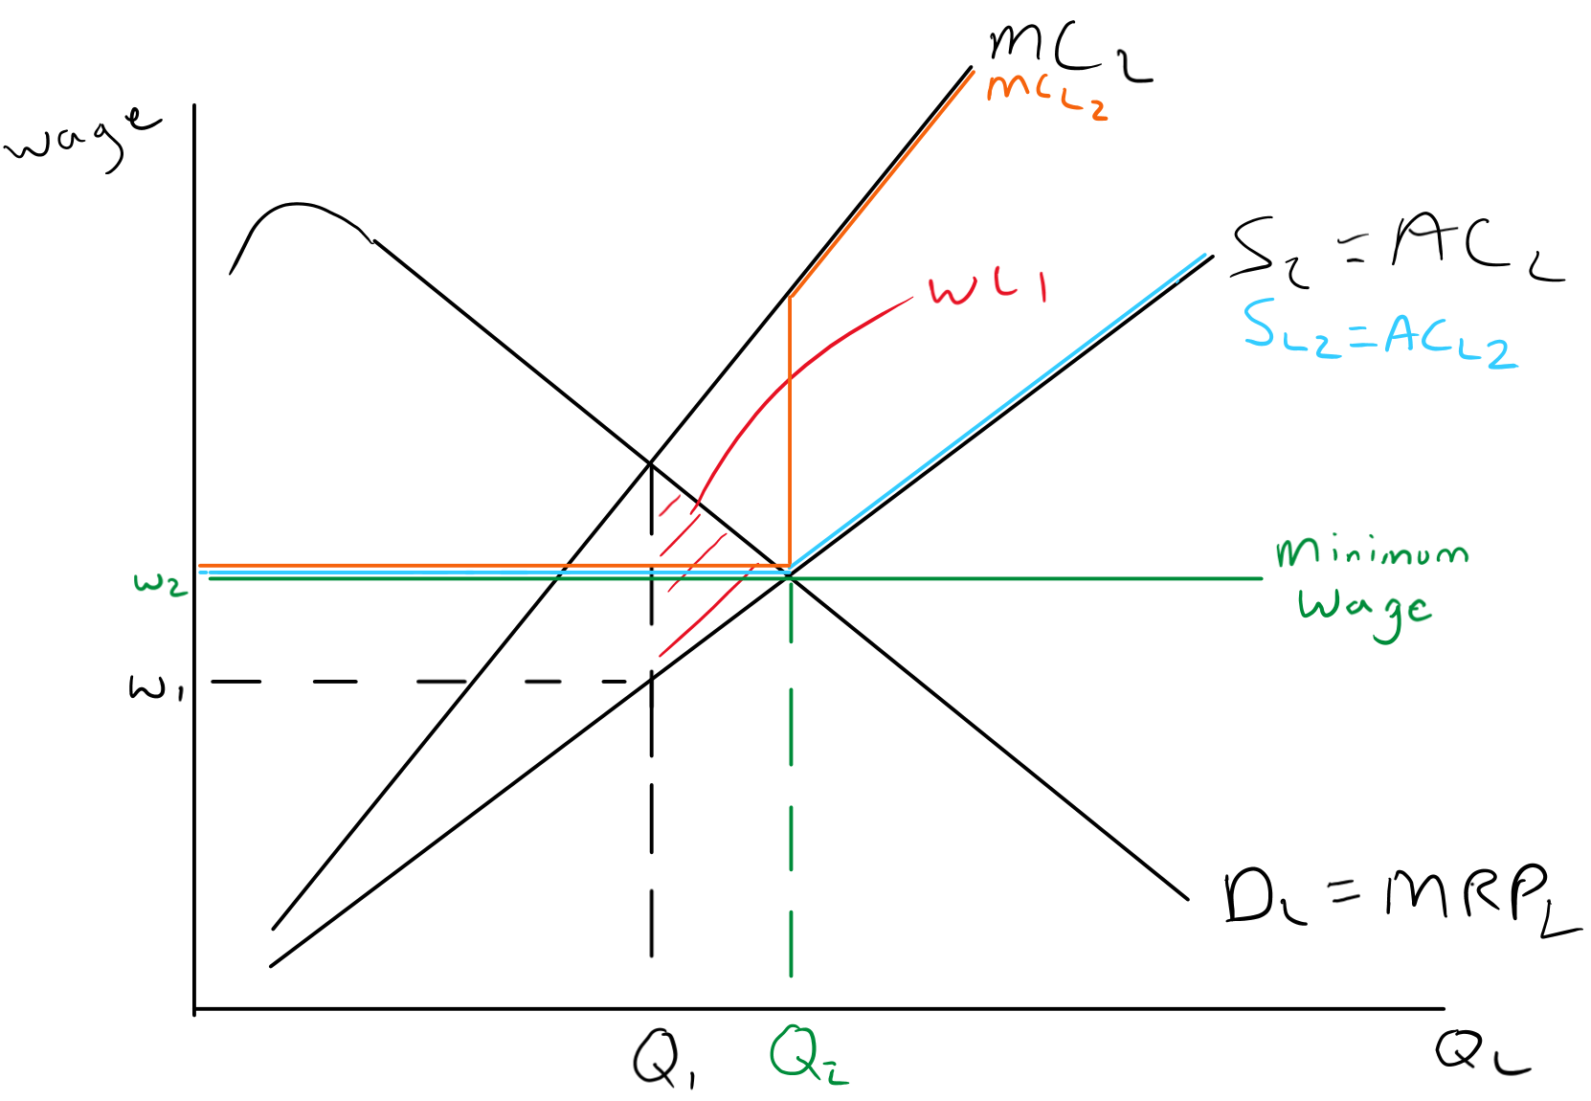
Wage TU
However, this is only the case if the agreed wage is below or equal to the competitive market equilibrium at SL=DL. Once the wage starts rising above that, then employment starts to fall again. Secondly, in the long run, big firms with monopsony power will be incentivised to replace workers with capital, reducing their demand for labour over time and possibly increasing unemployment. We have seen this already with guards being replaced with ticket barriers and autonomous tubes/trains might not be far behind.
Overall, the impacts of increased trade union power depend on the markets it affects and who in the economy we are looking at. For most of the low paid labour, a more powerful trade union will improve their earning power, lift people out of poverty, reduce inequality in the economy, and will even influence wages in other industries as well. If people can earn a higher wage for basic unionised jobs, then those in higher skilled work have more bargaining power to ask for more wages in their work to keep the wage differential constant. While some workers may lose their jobs, this is unlikely to happen in the short run as most unionised labour markets have some form of monopsony power (NHS, TfL, DforE). In the long run however, as capital becomes variable, firms might choose to replace labour with capital (ticket barriers instead of conductors), and we might see a greater increase in unemployment.
For firms an increase in trade union power will increase their costs and hurt their profitability. However, again this might only be in the short run (as they are more incentivised to invest in capital and increase productivity, this happens in France where trade union power is much is higher) and also the wage unions state that workers will become more productive with better training and protection.
Finally, an increase trade union power will have a small impact on most people in the UK. Workers in high earning jobs that are not unionised will not see any effects on their wages and only see an impact if the increase in trade union power leads to more strikes in public services or feeds through to an increase in prices leading to their real income falling.

